Nationale renstal

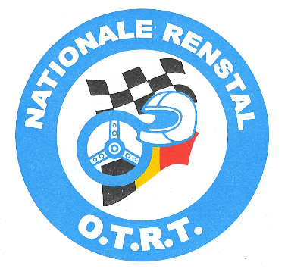

Oud-Turnhout Rally Team

Voorzitter Van Gestel Eric Secretaris Sels Jozef
Petrus Dielsstraat 30 Draaiboom 94
2360 Oud-Turnhout 2360 Oud-Turnhout
Tel/fax: 014 45 39 89 Gsm : 0477 59 27 19 Tel: 014 45 18 43 GSM O474 821229
E-mail: otrt@skynet.be E-mail: jozef.sels@skynet.be

Oud-Turnhout february 2025

I the undersigned, Sels Jozef, secretary of the Nationale Renstal O.T.R.T. grants full power to

if necessary , to send in complaint or to appeal during motor-car races organised in accordance with the F.I.S.A. and A.S.N. regulations.
The above mentioned pilot is authorized to use all rights, given to the competitor Nationale Renstal O.T.R.T. holder of the competitor licence racing team nr 697.663 of the Belgian N.S.K.

All charges in consequence of a complaint or an appeal in by above mentioned pilot, are for account of this pilot.

……………………… ……/……/……..

The pilot Secretary O.T.R.T.
Sels Jozef



